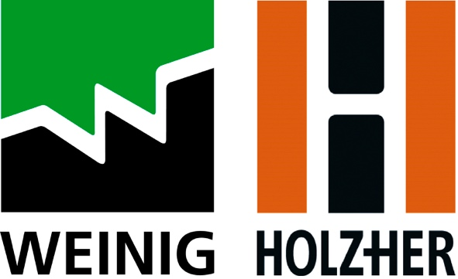

PRESS RELEASE

Immediate Release

Deputy mayor of London Opens BLOQS, the UK’s first open-access factory

The official opening of BLOQS, the UK’s first open-access factory, has taken place at its newly built 32,000sqft workspace in Enfield, London. The not-for-profit organisation, which has partnered with leading woodworking machinery manufacturer, Weinig UK, to offer its members the use of five state-of-the-art machines, saw Deputy Mayor, Jules Pipe cut the ribbon and tour the impressive facility alongside Enfield Council’s, Cllr Caliskan.
The new purpose-built workspace, which was designed in close collaboration 5th Studio, is the result of a three-way partnership and £4 million investment by The Mayor of London, Enfield Council and BLOQS - a social enterprise established in 2012 to empower and inspire makers who have suffered a steady decline in affordable industrial workspace in the capital.

The result is an innovative workspace that gives those in woodwork, metalwork, engineering, fashion and textiles, access to £1.3 million-worth of industrial equipment. This includes five machines from Weinig UK and Holz-Her UK, each with varying levels of automation, bridging the gap between BLOQS existing, traditional woodworking machinery and the very latest innovations in solid wood and panel processing.

A 3-axis Dynestic 7505 flatbed CNC, 5-axis Pro-Master 7125 CNC, Sector 1254 vertical panel saw, Cube Plus 4-sided planer and Streamer 1057 XL edgebander are now available for use, following a compulsory safety assessment and optional one-to-one training.

In an address to assembled guests and media, Jules Pipe said: “BLOQS is an innovative example of what can be achieved when businesses, boroughs and City Hall work together to add value to local communities and economies. The ability of our small businesses to rebuild and thrive will be a crucial element of London’s post-pandemic recovery and BLOQS gives businesses the space, materials and resources to do just that.”

Malcolm Cuthbertson, Managing Director of Michael Weinig (UK) Ltd says: “Being part of BLOQS transformation has been extremely rewarding. We saw this partnership as a way of giving something back to the industry, nurturing new talent and helping facilitate people’s journey’s within it. Today, we’ve seen several BLOQS members using Weinig and Holz-Her machinery in its new home and it was a pleasure to hear how the use of innovative technology like our is helping their businesses grow.”

BLOQS co-founder Al Parra adds: “From the very beginning, BLOQS has been about providing professional makers and their businesses the right space and facilities to grow and make a living. We’ve done this by gathering a community that shares resources, and what really distinguishes us from other open-access workspaces is that we’re designed specifically to enable commercial activity. With this new facility, we can give our community the space to make it work and we can create partnerships with education providers, manufacturers, suppliers, and our local communities. We’re deeply indebted and grateful to the many people and partners who have made this next step possible. We’re proud of how far we’ve come together and we can’t wait to show people around!”

For more information please visit weinig.co.uk or buildingbloqs.com.

