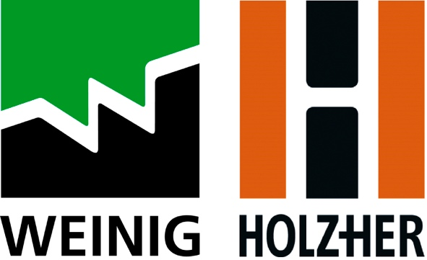

PRESS RELEASE

Immediate Release

Weinig: Driving Change

Andy Driver knows his craft. For over 30 years, he’s run a successful specialist joinery business and is regularly commissioned to work on listed buildings and grand period properties. But, in the wake of a global pandemic and faced with a rapidly changing market, now more than ever, smaller businesses like Andy’s have been looking to reduce costs and combat the industry’s skills shortage by simplifying their manufacturing processes. For the Norfolk-based joiner, this has meant investing in the UK’s very first Profimat 30 moulder from Weinig UK.

“After 15 years, 2021 was the right time to replace my trusted Weinig VarioMat four-sided planer,” begins Andy, owner of AJ Driver Joinery Ltd. “We’ve been facing a growing skills shortage in the woodworking industry for a number of years. The pandemic has amplified this problem and has been a driving force behind changes to my business.”

Andy concedes machines that require a skilled operator are no longer a viable choice for his business. “There is no longer a pool of people with the right skill-set to work machines like this,” he says. “My VarioMat was a reliable workhorse but I knew I needed to invest in a new moulder that could be operated by someone with minimal machining experience. It also needed to offer quick set-up and the same machining capabilities and build quality my old machine had.” Additional requirements also included the need to machine 300 metres of 125 x 70mm hard and soft wood at a time and create extremely accurate and intricate moulds for traditional glazed windows using Accoya. It also had to be compact in size and offer a relatively quick return on investment.

After reading about the newly-launched moulder during the first lockdown, Andy was confident that the Profimat 30 was the right fit for his business. With a base footprint of 1.5 x 1.3 metres, Weinig’s powerful, cast-iron-framed entry-level moulder has been engineered with the smaller manufacturer in mind. It features five spindle , a working height of 8-120mm and a standard working width of 13-230mm (an optional working width of 260mm is also available). Andy says, “It offered the machining versatility I needed and the German build quality I had come to expect from Weinig.”

The moulder’s innovative technology and easy set-up was also a big selling point. “Technology has come a long way in 15 years and standard features on the Profimat 30, like frequency converters to start and stop the spindle drives and reduce power peaks, a single button to start/stop the motors and save energy and a clever 5mm thick lateral guiding fence that moves with the left spindle, were simply not an option then.

“The old machine was manually operated. It couldn’t store data so it had to be set-up for a given profile. It also didn’t tell you which block to put on which head. You needed a good understanding of the machine to run it to its full potential. With the Profimat 30, it does the work for you.”

Specified with the Control Package – which combines CNC positioning for width and thickness, electronic digital displays and a 10.1” touch screen – and Weinig’s Memory Plus system, which gives Andy the option to save up to 500 different profile settings directly onto the machine, the operator simply needs to follow the on-screen instructions before machining can begin. “It’s exceptionally user-friendly and we no longer need a dedicated machinist to run the moulder. Instead, after two days of training given by Weinig, the whole team was more than capable of running the machine.”

“This machine has been designed by someone who understands what smaller manufacturers want,” says Andy. “It isn’t over-engineered or complicated to use. It has been created to do a job and it does that job very well. It’s four-sided planing is as good as it gets and its accuracy and build quality is second to none. Running costs are also minimal and thanks to its simple colour-coded display and pre-programable settings, set-up is twice as quick as our last model. The extra-cost Servo Lock has also speeded up the loosening and tightening of spindle nuts when tools need to be changed and is a remarkable piece of kit.”

Andy adds, “The relationship I have with Weinig is exceptional. They go above and beyond for their customers and their product knowledge is outstanding. It’s this, plus their ongoing support and service, that has – and will continue – to see me invest in them. For a smaller manufacturer, there is something very reassuring about knowing Weinig are always there.

For more information please visit www.weinig.co.uk.

-END-

CAPTIONS:

2814 Removing a cutter block.jpg
Weinig’s unique Servo Lock has speeded up the loosening and tightening of spindle nuts.
2764 Andy Driver removing the spindle cover.jpg
Easy access and digital readout make for simple operation.

